 | 21013 GALLARATE (VA) - ITALIA  Via Cappuccini, 50/A | REQUEST DATE

*QUANTITY

DENSITY (yarn/cm) |  |  |  |  | TYPE OF FABRIC
JACQUARD TYPE |  |  |  | STAUBLI - BONAS OTHER (specificate)
JACQUARD MODEL AND SIZE
COMBERBOARDS WIDTH |  |  | STANDARD (160mm) - NON STANDARD (<200mm specificate)
DRILLING DEPTH
NOTE

*QUANTITY is expressed in plates or meter, anyhow plates are cutted up to 40 cm to decrease the remaining waste.
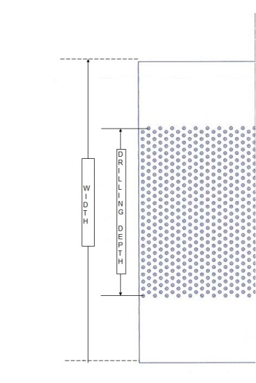
*FOR MULLER MACHINE is necessary to complete the schema in a separate page

